Davaakhuu Undarmaa です。課題について:
1. https://tokuron-2025.v25y0009.workers.dev/github-models
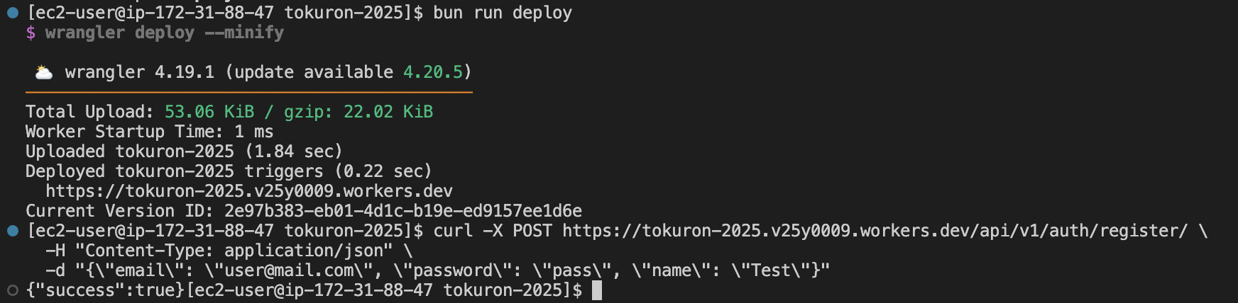

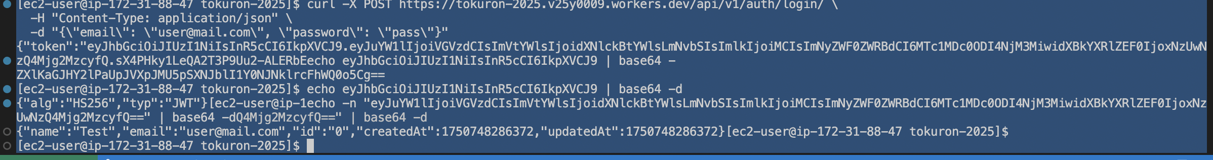
[ec2-user@ip-172-31-88-47 tokuron-2025]$ curl -X POST https://tokuron-2025.v25y0009.workers.dev/api/v1/auth/login/ \
-H "Content-Type: application/json" \
-d "{\"email\": \"user@mail.com\", \"password\": \"pass\"}"

[ec2-user@ip-172-31-88-47 tokuron-2025]$ echo eyJhbGciOiJIUzI1NiIsInR5cCI6IkpXVCJ9 | base64 -d
{"alg":"HS256","typ":"JWT"}[ec2-user@ip-172-31-88-47 tokuron-2025]$
echo"eyJuYW1lIjoiVGVzdCIsImVtYWlsIjoidXNlckBtYWlsLmNvbSIsImlkIjoiMCIsImNyZWF0ZWRBdCI6MTc1MDc0ODI4NjM3MiwidXBkYXRlZEF0IjoxNzUwNzQ4Mjg2MzcyfQ==" | base64 -d
{"name":"Test","email":"user@mail.com","id":"0","createdAt":1750748286372,"updatedAt":1750748286372}[ec2-user@ip-172-31-88-47 tokuron-2025]$

